Valeriy Kutsar Socket 3

screenshot of client working in terminal

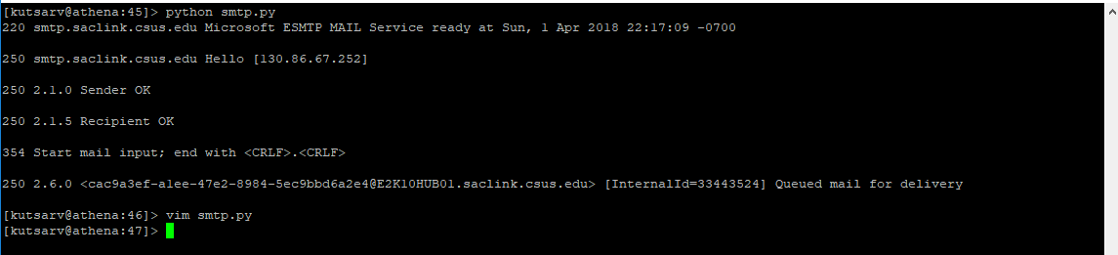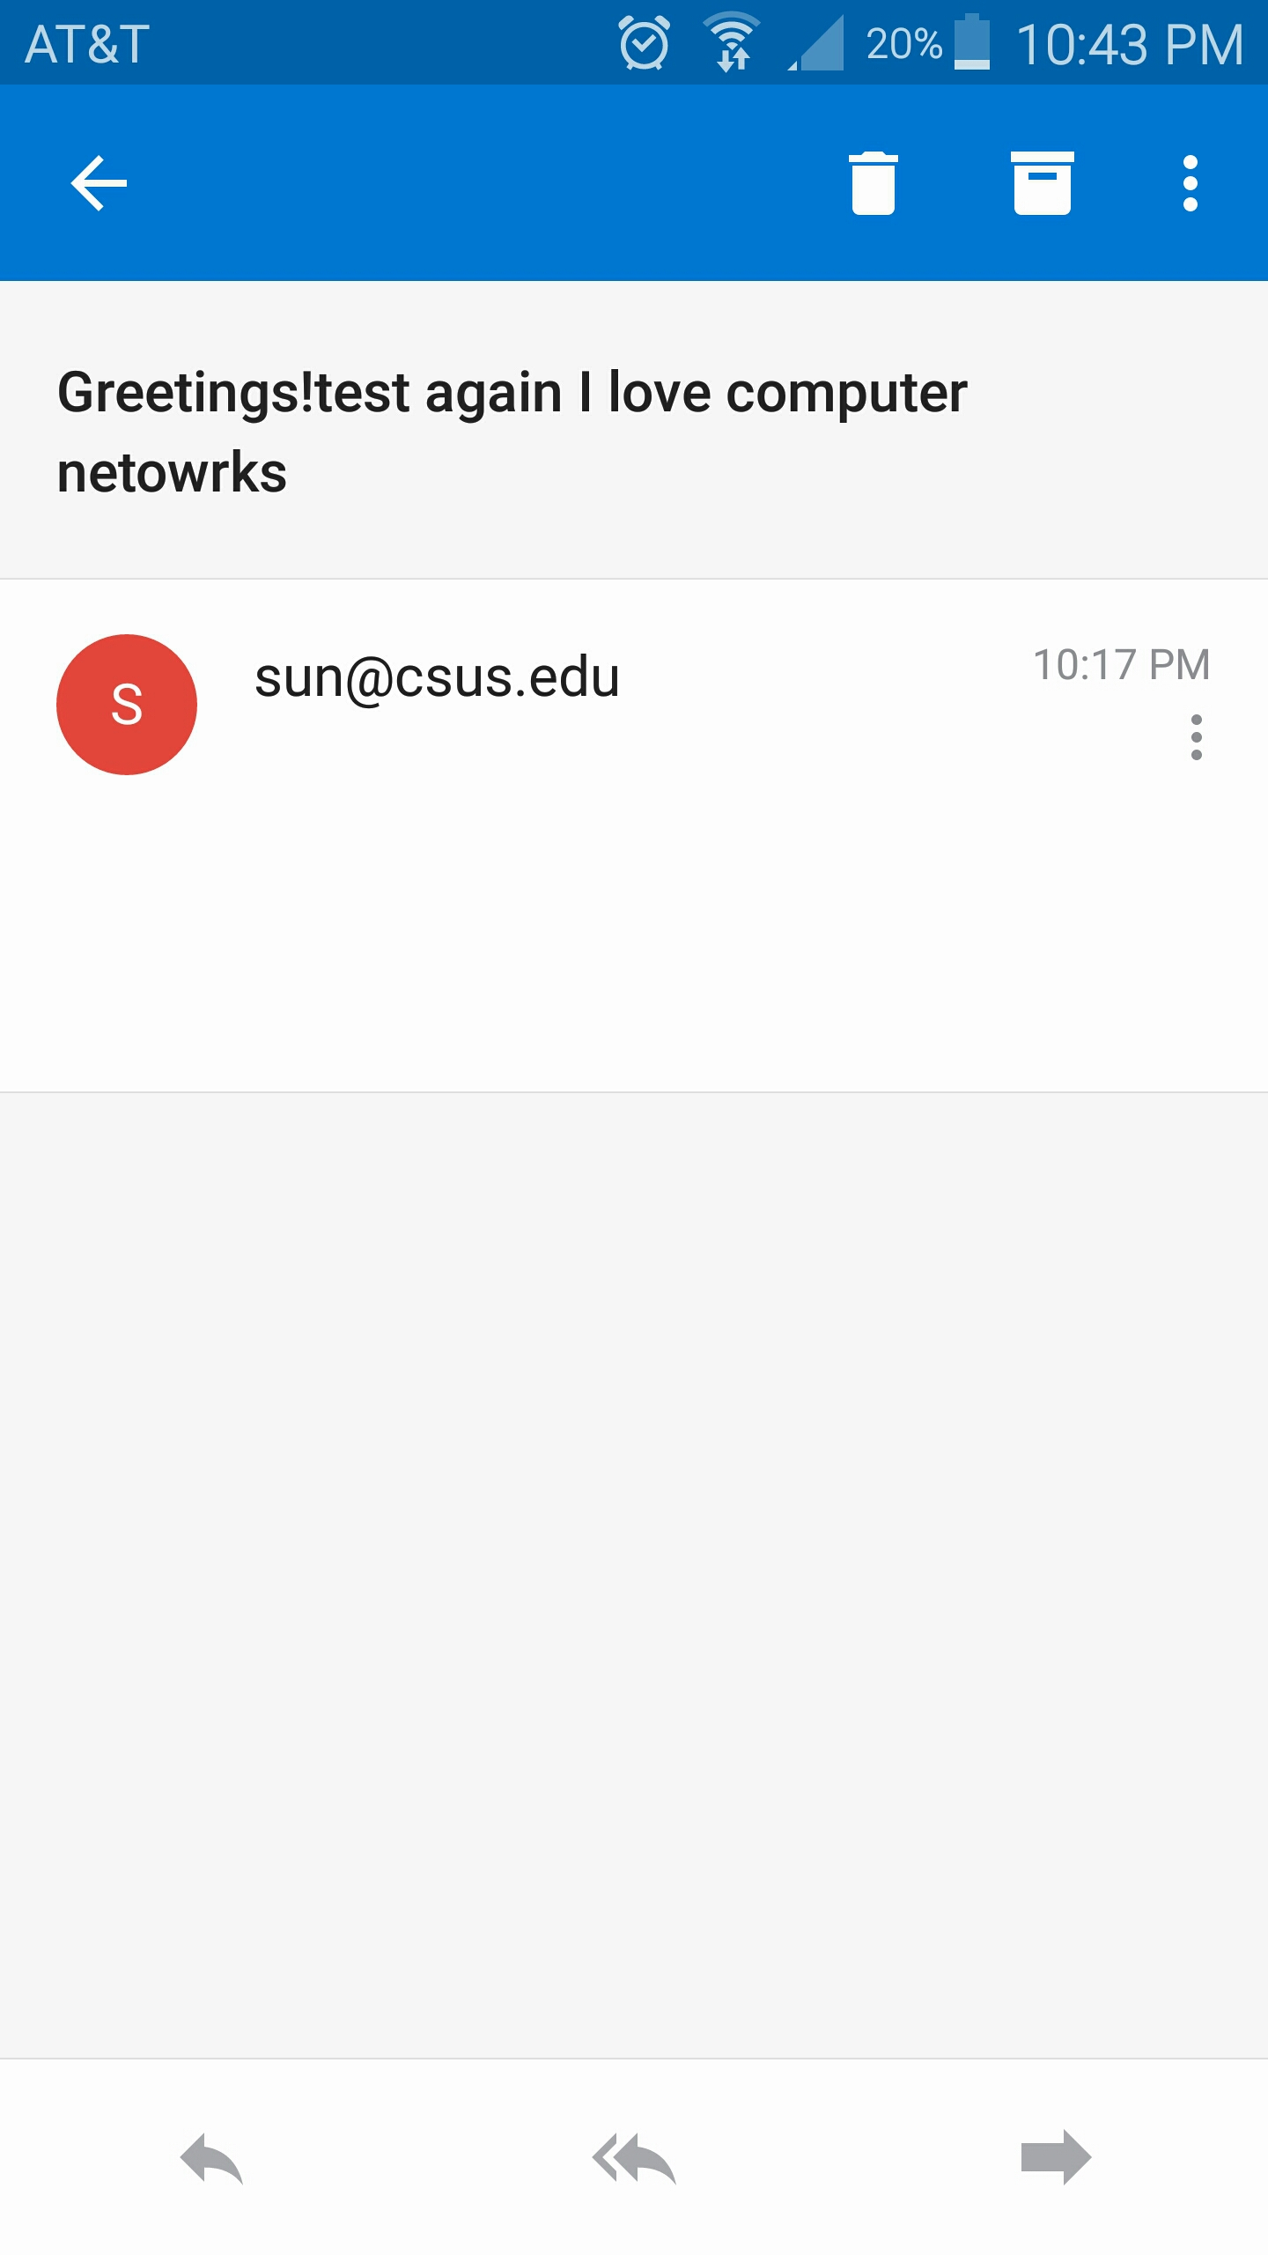

Screenshot of proof of reception of email from smtp